SCD Type-2:
Skey Generate Formula: (@NUMPARTITIONS*(@INROWNUM-1))+ @PARTITIONNUM
Image 1
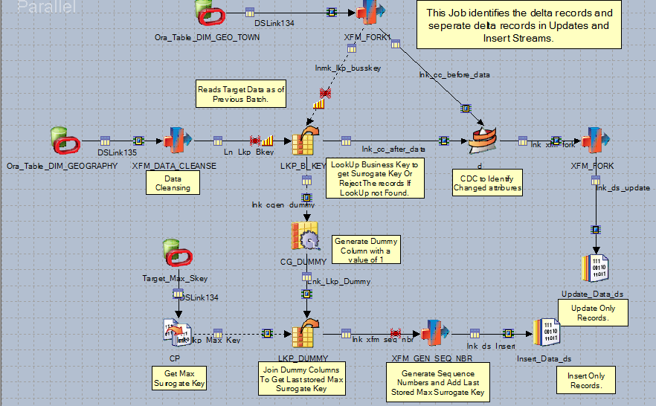
Image2
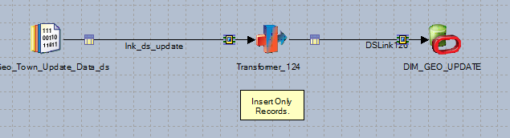

Image 3
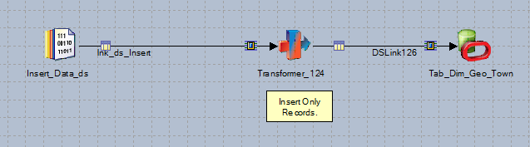

Source Table: DIM_GEOGRAPHY
Target Table: DIM_GEOGRAPHY_TOWN

Source Table DDL:
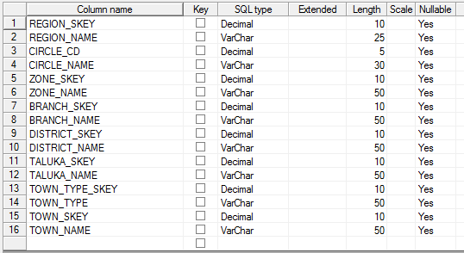

Reference Table (Before data)DDL
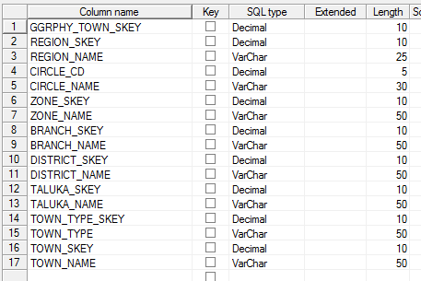

Target Table DDL:
